1. a.<!doctype html>

<html>

<head>

<meta charset="utf-8">

<title>JavaScript program to extract the first half of a string of even length.</title>

</head>

<body>

<script>

function first_half (str) {

if (str.length % 2 == 0) {

return str.slice(0, str.length / 2);

}

else{

alert("Enter string of even length.");

}

return "Try Again.";

}

var x=prompt("Enter a string ");

document.write(first_half(x));

</script>

</body>

</html>

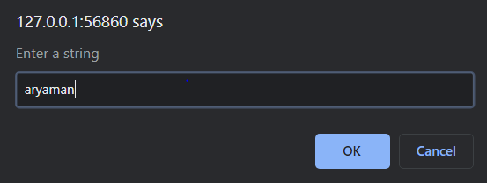

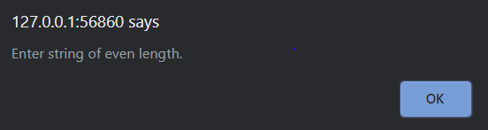

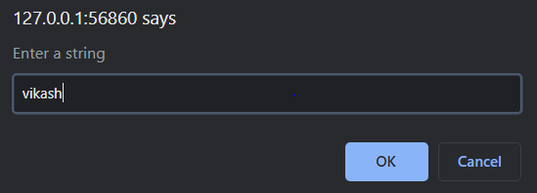

b) <!doctype html>

<html>

<head>

<meta charset="utf-8">

<title>JavaScript program to concatenate two strings except their first character.</title>

<script>

function concatenate(str1, str2) {

str1 = str1.substring(1, str1.length);

str2 = str2.substring(1, str2.length);

return str1 + str2;

}

var x=prompt("Enter a string 1");

var y=prompt("Enter a string 2");

var res=concatenate(x,y);

document.write(res);

</script>

</head>

<body>

</body>

</html>

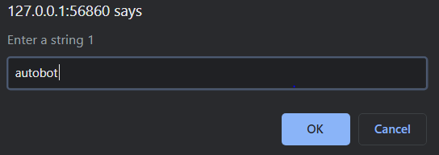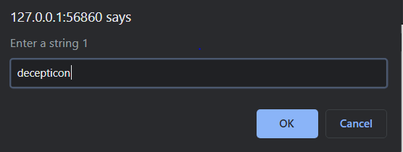



c)

<!doctype html>

<html>

<head>

<meta charset="utf-8">

<title>JavaScript program to check a given string contains 2 to 4 numbers of a specified character.</title>

<script>

function check_char(str1, char)

{

ctr = 0;

for (let i = 0; i < str1.length; i++)

{

if ((str1.charAt(i) == char) && (i >= 1 && i <= 3))

{

ctr=1;

break;

}

}

if (ctr==1) return true;

return false;

}

var x=prompt("Enter a string");

var y=prompt("Enter a character.")

var res=check_char(x,y);

document.write(res);

</script>

</head>

<body>

</body>

</html>

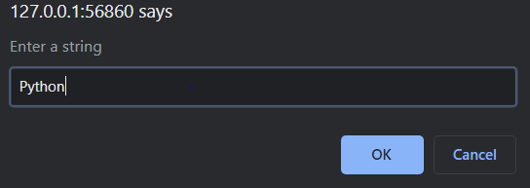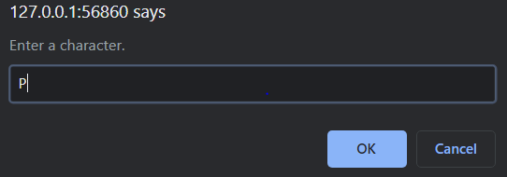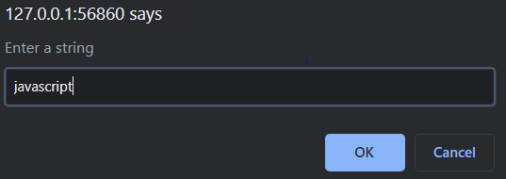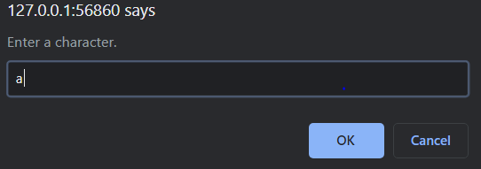



d)

<!doctype html>

<html>

<head>

<meta charset="utf-8">

<title>Compare two objects to determine if the first one contains equivalent property values to the second one</title>

</head>

<body>

<script>

const matches = (obj, source) =>

Object.keys(source).every(key => obj.hasOwnProperty(key) && obj[key] === source[key]);

document.write(matches({ age: 25, hair: 'long', beard: true }, { hair: 'long', beard: true })); // true

document.write(matches({ hair: 'long', beard: true }, { age: 25, hair: 'long', beard: true })); // false

document.write(matches({ hair: 'long', beard: true }, { age: 26, hair: 'long', beard: true })); // false

</script>

</body>

</html>



2) <!DOCTYPE html>

<html>

<head>

<meta charset="utf-8" />

<title>JavaScript program to calculate arithmetic operations </title>

<style type="text/css">

body {margin: 30px;}

td, th {border: 1px solid;

padding: 10px;

min-width: 200px;

background: white;

box-sizing: border-box;

text-align: left;

}

table {border-collapse: collapse; font-family: helvetica}

tbody {

overflow: scroll;

height: 200px;

}

</style>

</head>

<body>

<form>

<table width="200" border="1">

<tbody>

<tr>

<th scope="col">1st Number :</th>

<th scope="col"><input type="text" id="firstNumber" /></th>

<th scope="col"><input type="button" onClick="calculate()" Value="Calculate" /></th>

</tr>

<tr>

<th scope="row">2nd Number:</th>

<td><input type="text" id="secondNumber" /></td>

<td><input type="reset" value="Reset"></td>

</tr>

<tr>

<th scope="row">Addition: </th>

<td><span id = "result1"></span></td>

<td>&nbsp;</td>

</tr>

<tr>

<th scope="row">Subtraction:</th>

<td><span id = "result2"></span></td>

<td>&nbsp;</td>

</tr>

<tr>

<th scope="row">Multiplication:</th>

<td><span id = "result3"></span></td>

<td>&nbsp;</td>

</tr>

<tr>

<th scope="row">Division:</th>

<td><span id = "result4"></span></td>

<td>&nbsp;</td>

</tr>

</tbody>

</table>

</form>

<script>

function calculate()

{

num1 = document.getElementById("firstNumber").value;

num2 = document.getElementById("secondNumber").value;

num1=Number(num1);

num2=Number(num2);

document.getElementById("result1").innerHTML = num1 + num2;

document.getElementById("result2").innerHTML = num1 - num2;

document.getElementById("result3").innerHTML = num1 * num2;

document.getElementById("result4").innerHTML = num1 / num2;

}

</script>

</body>

</html>

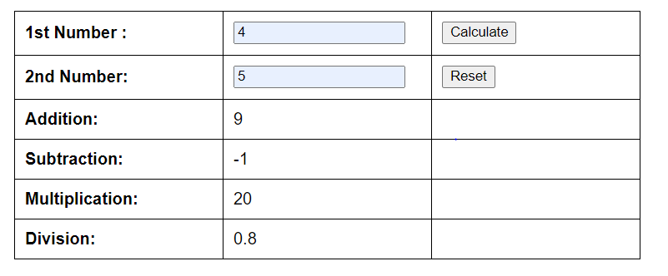

Reset button☹on pressing

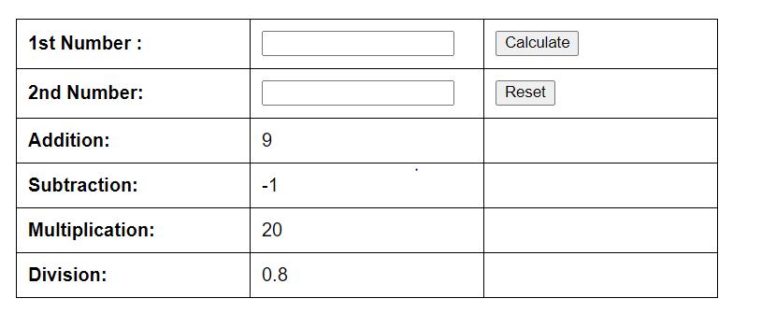

3) <!doctype html>

<html>

<head>

<meta charset="utf-8">

<title>Array to filter only Integers</title>

<script>

let array = [1, 'a', '1', 3, NaN, 3.1415, -4, null, false];

let newArray = removeNonInteger(array);

document.write(newArray);

function removeNonInteger(array) {

return array.filter(Number.isInteger);

}

</script>

</head>

<body>

</body>

</html>



4) <!doctype html>

<html>

<head>

<meta charset="utf-8">

<title>Find Largest name</title>

</head>

<body>

<script>

var arr=[];

var len_max,large_name;

var x=prompt("Enter number of names of policy holders.");

for(var i=0;i<x;i++)

{

arr.push(prompt("Enter name:"));

}

len_max=arr[0].length;

for(var i=0;i<x;i++)

{

if(arr[i].length > len_max)

{

large_name=arr[i];

}

}

document.write("Longest Name:")

document.write(large_name);

</script>

</body>

</html>

